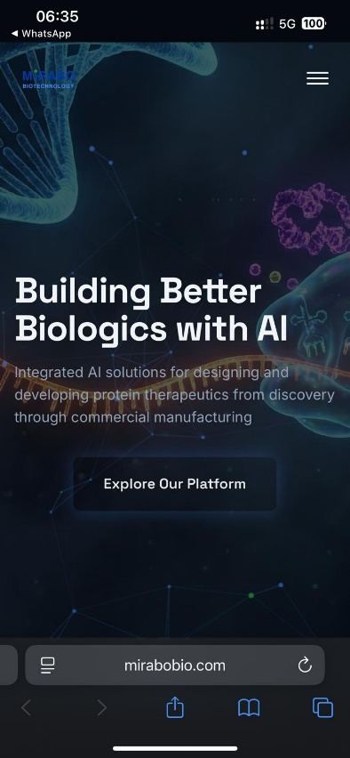

“The dark logo is completely invisible against the dark background. Please either switch to a white logo or change the background.”
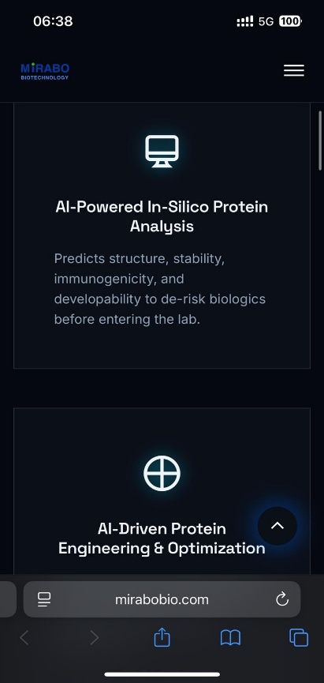
The three icons do not match the context at all. Since it is already clear that everything is AI-based, the emphasis should be placed on the verbs and the icons should be redesigned accordingly. As they are now, the icons make it look like an IT company, and it is impossible to understand what the message is.”

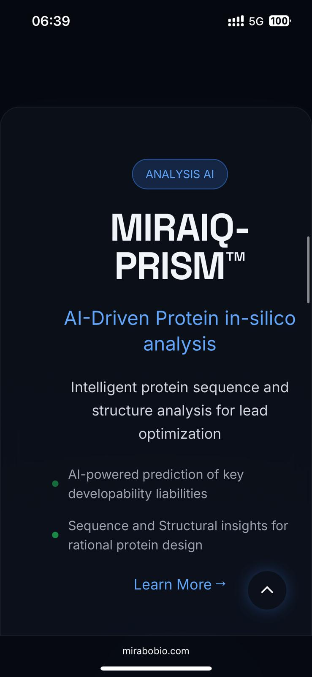

“The center alignment is broken.”

“The page that opens when you click ‘View Details’ for MIRAIQ PRISM has very poor readability — the content is barely visible
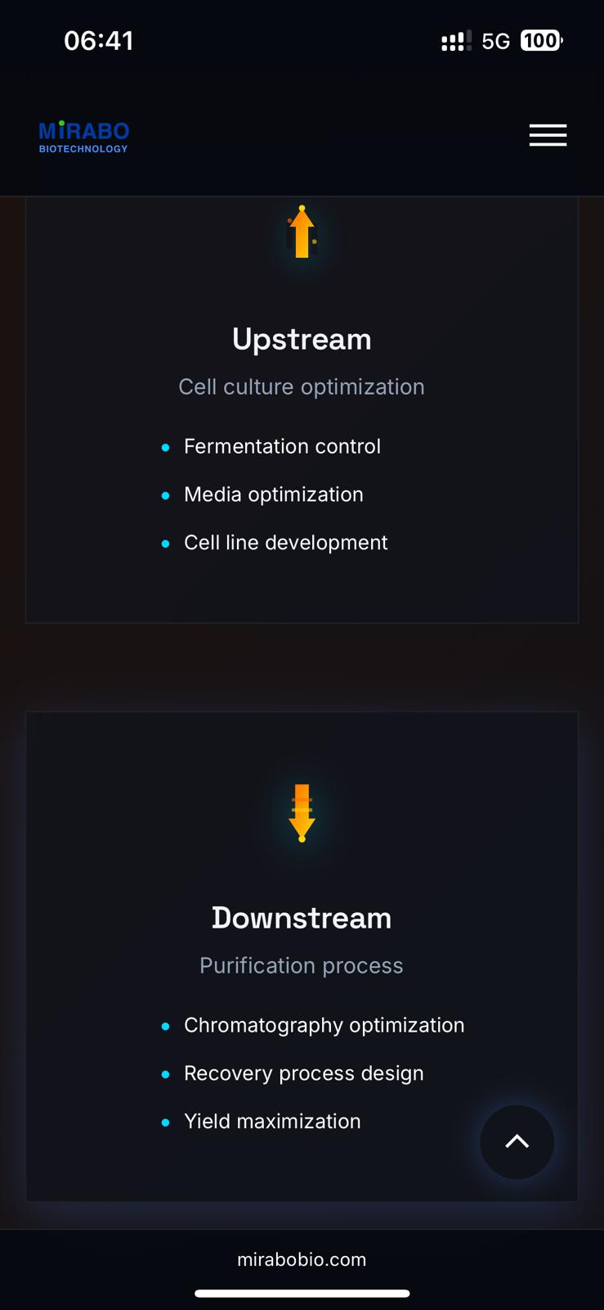

“The icons feel negative; they look more like weaknesses than strengths.”
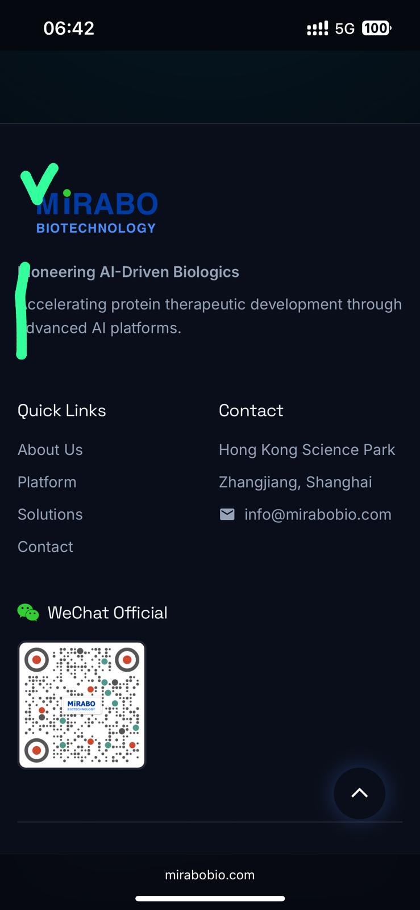
Logos needs to be aligned.



“The gray text has almost no readability. I recommend adding a black gradient at the bottom and placing white text on top.”
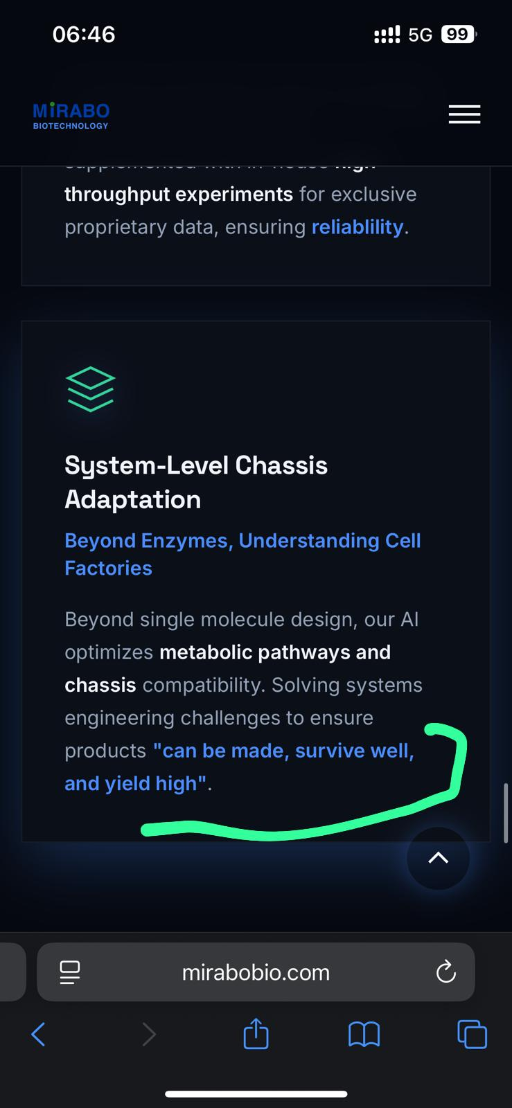
“The body text uses too many different bold styles for emphasis, which looks messy. It would be better to use one consistent bold style—and start the emphasis from ‘made.’”

